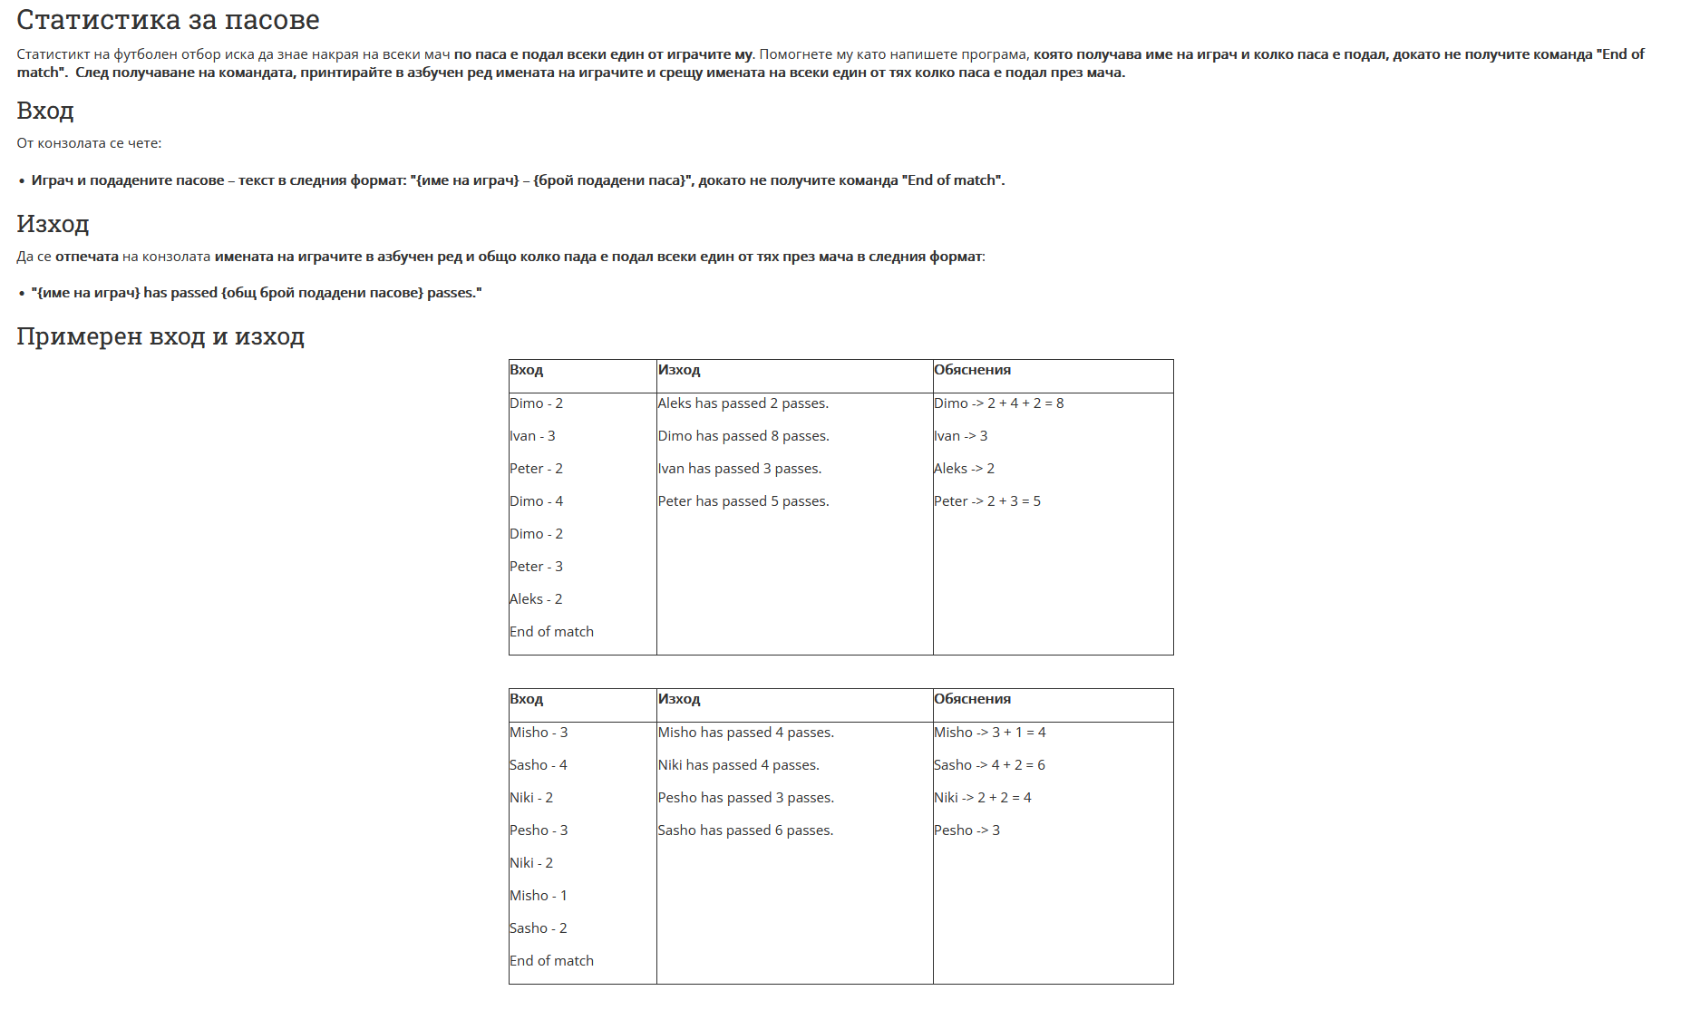

using System;

using System.Collections.Generic;

using System.Linq;

namespace ConsoleApp243

{

class Program

{

static void Main(string[] args)

{

bool checkForStop = true;

var team = new Dictionary<string, int>();

while (checkForStop)

{

string[] currentName = Console.ReadLine().Split(" - ").ToArray();

string check = string.Join(" ", currentName);

if (check == "End of match")

{

checkForStop = false;

}

else

{

if (!team.ContainsKey(currentName[0]))

{

int passes = int.Parse(currentName[1]);

team.Add(currentName[0], passes);

}

else

{

int num = int.Parse(currentName[1]);

team[currentName[0]] += num;

}

}

}

List<string> final = new List<string>();

foreach(var name in team)

{

final.Add($"{name.Key} has passed {name.Value} passes.");

}

final.Sort();

for (int i = 0; i < final.Count; i++)

{

Console.WriteLine(final[i]);

}

}

}

}